https://students.ashworthcollege.edu/

Username: Carriegilles@ymail.com
Password: 133Angelina

Once you login in, if you scroll down in the center, it says courses, then click on Algebra 1: Part 2
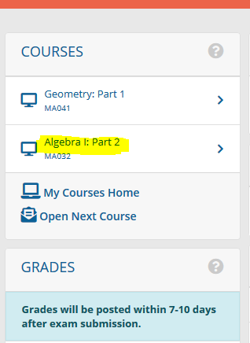

It will then bring you to a Homepage. Click on the assignment tab and then quizzes.
It will be Lessons 4 & 5 Exam, Lesson 6 Exam and the Final Exam

